
PERIODIC TEST 3 (2021-22)
ANSWER KEY
Subject: PHYSICS  Grade: XII |  | Max. Marks: 35  Time: 1 Hr 10 Minutes
SECTION A
1. | How are microwave produced?  - klystron and magnetron valve  - sudden deceleration of electron in x- ray tube  - accelerated motion of charge in conducting wire  - hot bodies and molecule |  | 1
2. | In an electromagnetic wave  - E and B are parallel to each other  - E is parallel to the direction of propagation  - Speed is independent of the nature of medium  - Speed decreases with increase in dielectric constant of the medium |  | 1
3 | Angle of prism is 60°. What will be minimum angle of deviation for this prism ? Refractive index of prism is √2.  - 45°  - 30°  - 60°  - 35 |  | 1
4 | The optical density of turpentine is higher than that of water while its mass density is lower. Fig: shows a layer of turpentine floating over water in a container. For which one of the four rays incident on turpentine in Fig the path shown is correct?  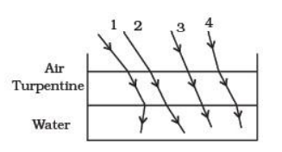  (a) 1 (b) 2 (c) 3 (d) 4 |  | 1
5 | Which of the following statement is not true.  - Optical fibres is based on the principle of total internal reflection.  - The refractive index of the material of the core is less than that of the cladding.  - an optical fibre can be used to act as an optical pipe.  - there is no appreciable loss in the intensity of the light signal while propagating through an optical fibre |  | 1
6 | The aperture of the objective lens of an astronomical telescope is doubled. How does it affect the resolving power of the telescope?  The resolving power is doubled  R.P.=D/1.22λ |  | 1
7 | Draw the shape of the reflected wave front when a plane wave front is incident on a concave lens.  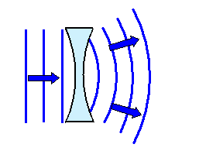 |  | 1
8 | For the same angle of incidence, the angle of refraction in three different media A, B and C are 15 º, 25 º and 35 º . In which medium, will the velocity light be minimum?  From Snell's law n = sini/sinr = c/v For given i,v ∝ sinr; r is minimum in medium A, so velocity of light is minimum in medium |  | 1
9 | The focal length of an equiconvex lens is equal to the radius of curvature of either face. What is the refractive index of the material of the lens?  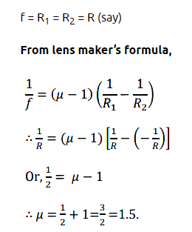 |  | 1
10 | In a single slit diffraction experiment, the width of the slit is reduced to half its original width. How would this affect the size and intensity of the central maximum?  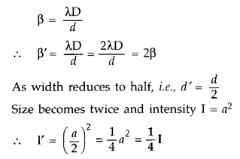 |  | 1
11 | A ray of light is incident normally on the face AB of a right-angled glass prism of refractive index aμg = 1·5. The prism is partly immersed in a liquid of unknown refractive index. Find the value of refractive index of the liquid so that the ray grazes along the face BC after refraction through the prism. Trace the path of the rays if it were incident normally on the face AC  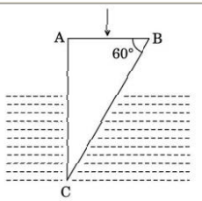  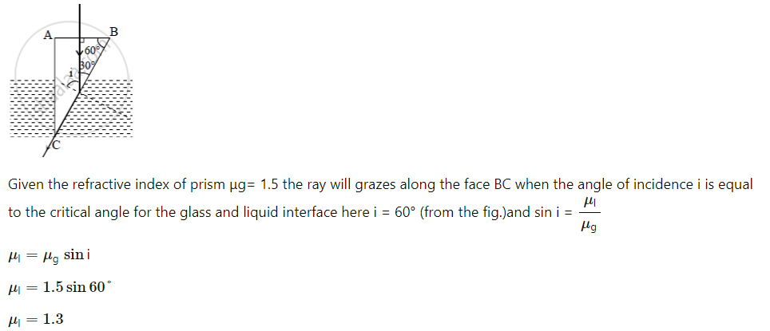  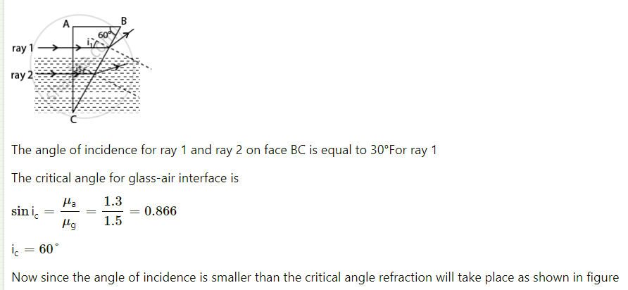 |  | 2
12 | A concave lens has the same radii of curvature for both sides and has refractive index 1.6 in air. In the second case, it is immersed in a liquid of refractive index 1.4. Calculate the ratio of the focal length of the lens in the two cases.  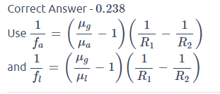 |  | 2
13 | State Huygens principle. Using geometrical construction of secondary wavelets, explain the reflection of a plane wave front incident at a plane surface. |  | 2
14 | In Young’s double-slit experiment using monochromatic light of wavelength λ, the intensity of light at a point on the screen where path difference is λ, is K units. What is the intensity of light at a point where path difference is λ/3?  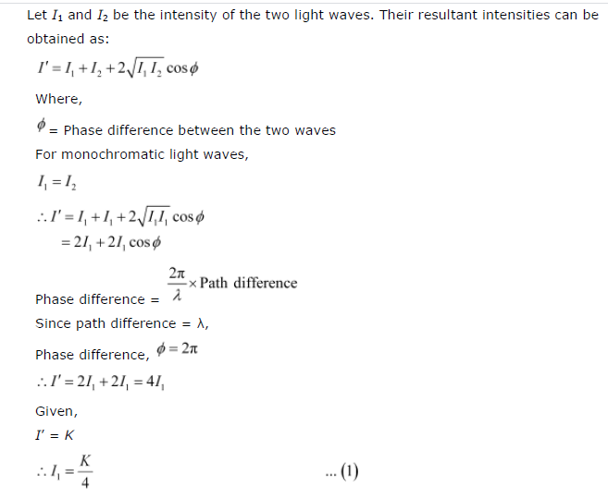  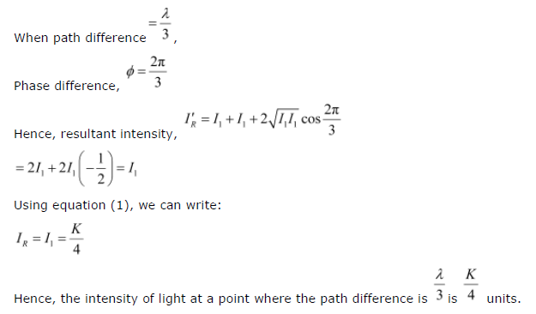 |  | 2
15 | a. How are electromagnetic waves produced?  b. The oscillating electric field of an electromagnetic wave is given by  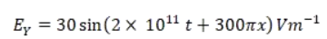  i) Write down the expression for oscillating magnetic field.  ii) Sketch the corresponding em wave with its electric field and magnetic field.  - Accelerated charge particles oscillating in a changing electric and magnetic field.  - (i) B = 10-7 Sin( 2x 10 11t + 300πx) T  (ii) 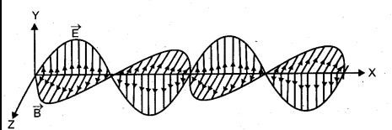 |  | 3
16 | - Draw a schematic ray diagram of a compound microscope when image is formed at distance of distinct vision  - A person with a normal near point (25cm) using a compound microscope with objective of focal length 8mm and an eye piece of focal length 2.5cm can bring an object placed at 9mm from the objective in sharp focus. What is the separation between the two lenses. Calculate the magnifying power of the microscope.  a.Diagram  b.  b. 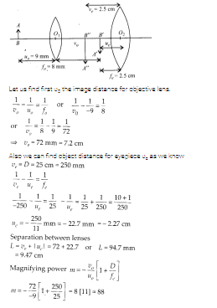 |  | 3
17 | With the help of a proper labelled diagram, derive an expression for refraction at a spherical surface if the ray of light is travelling from rarer to denser medium. |  | 3
18 | - A parallel beam of monochromatic light falls normally on a narrow slit and light coming out of the slit is obtained on the screen. Derive an expression for the angular width of the central bright maxima obtained on the screen.  - Find the half angular width of the central bright maximu in the Fraunhofer diffraction pattern of a slit of width 12x 10-5cm when the slit is illuminated by monochromatic light of wavelength 6000A.  - Derivation  A sinϴ= nλ ϴ = 30 |  | 3
19 | (a) State the importance of coherent sources in the phenomenon of interference of light.  (b) In Young’s double slit experiment, obtain the conditions for constructive and destructive interference. Hence deduce the expression for the fringe width.  (c ) In a Young’s double-slit experiment, the slits are separated by 0.28 mm and the screen is placed 1.4 m away. The distance between the central bright fringe and the fourth bright fringe is measured to be 1.2 cm. Determine the wavelength of light used in the experiment.  - To observe interference fringe pattern, there is need to have coherent sources of light which can produce light of constant phase difference.  - Derivation  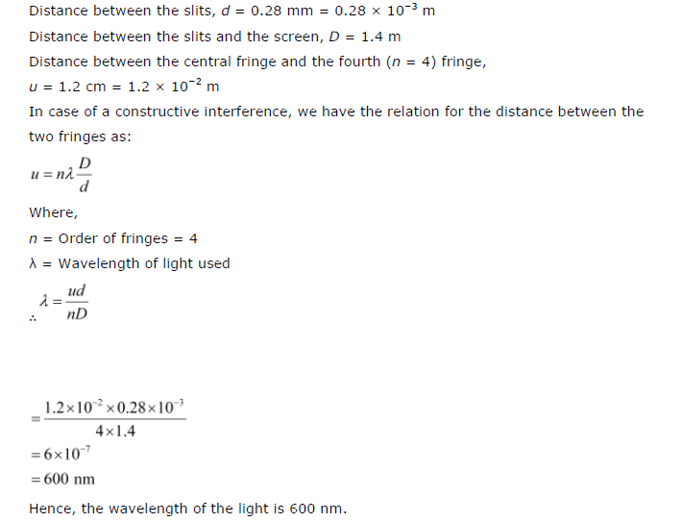 |  | 5

